Computer Architecture Lab
(EL-2012)
LABORATORY REPORT

Fall 2026

(Lab#07)
Implementation of Arithmetic Logic Unit (ALU)
Execution

Student Name: Muhammad Hamza Roll No: 24i-6513 Section: B

Date performed: 7 , Octuber , 2026

MARKS AWARDED: ________ / 10

Signature and date of Instructor: _________________
Lab Instructors: Dr. Nasir Ali Shah, Engr. Fasih Ahmad

______________________________________________________________________________________________________________________________________________________

NATIONAL UNIVERSITY OF COMPUTER AND EMERGING SCIENCES, ISLAMABAD
Prepared by: | Fasih Ahmad |  | Version: 1.0
Verified by: | Dr. Nasir Ali Shah |  | Updated: Fall 2026

Task 1:

Description:
This task implements a 1-bit Arithmetic Logic Unit using Verilog gate-level modeling.
It performs addition, subtraction, AND, and OR operations. A separate adder module handles arithmetic using XOR, AND, and OR gates.A 2-bit opcode selects the required operation through multiplexer logic.A testbench checks the results for different input combinations.

Code:
module adder_1bit(input A , input B , input cin , input b_in , output res , output cout );

// M for enable bit which it is one then it will do substraction and
// if it is zero it will do addition
// The cin and M must be same
wire B_invert;

xor(B_invert , B , b_in);

wire r1, a1 , a2 ;

xor (r1, B_invert , A );

and(a1 , A , B_invert);

xor( res , r1, cin) ;

and(a2 , r1 , cin);

or(cout , a1 , a2);

endmodule

module Alu_1bit(input A , input B , input c_in , input b_in, input [1:0] op_code , output result , output cout);

wire and_result, or_result ;
wire add_result, add_cout;

// Logical operations for Anding and ORing
and (and_result, A, B);
or (or_result, A, B);

adder_1bit add1 (
.A(A),
.B(B),
.cin(c_in),
.b_in(b_in),
.res(add_result),
.cout(add_cout)
);

// MUX selection logic
wire s0_not, s1_not;
wire w0, w1, w2;

not (s0_not, op_code[0]);
not (s1_not, op_code[1]);

// Seclecting addition/ substractio when opcode is 00 and b_in well cause addition or substraction
and (w0, add_result, s1_not, s0_not);

// Selecting and result when op_code is 01
and (w1 ,and_result , s1_not ,op_code[0]);

// Selecting or result when op_code is 10

and (w2, or_result , op_code[1] , s0_not);

or (result , w0 , w1 , w2);

// buf will copy add_cout to cout
buf (cout , add_cout);

endmodule

module tb;

reg A, B, c_in, b_in;
reg [1:0] op_code;

wire result, carry_out;

Alu_1bit uut (
.A(A),
.B(B),
.c_in(c_in),
.b_in(b_in),
.op_code(op_code),
.result(result),
.cout(carry_out)
);

initial begin

// Test 1: ADD 0 + 0
A=0; B=0; c_in=0; b_in=0; op_code=2'b00;
#10;

// Test 2: ADD 1 + 0
A=1; B=0; c_in=0; b_in=0; op_code=2'b00;
#10;

// Test 3: ADD 1 + 1
A=1; B=1; c_in=0; b_in=0; op_code=2'b00;
#10;

// Test 4: SUB 1 - 1
A=1; B=1; c_in=1; b_in=1; op_code=2'b00;
#10;

// Test 5: SUB 0 - 1
A=0; B=1; c_in=1; b_in=1; op_code=2'b00;
#10;

// Test 6: AND 1 & 1
A=1; B=1; c_in=0; b_in=0; op_code=2'b01;
#10;

// Test 7: AND 1 & 0
A=1; B=0; c_in=0; b_in=0; op_code=2'b01;
#10;

// Test 8: OR 1 | 0
A=1; B=0; c_in=0; b_in=0; op_code=2'b10;
#10;

// Test 9: Reserved operation
A=0; B=0; c_in=0; b_in=0; op_code=2'b11;
#10;

end

endmodule

Output:
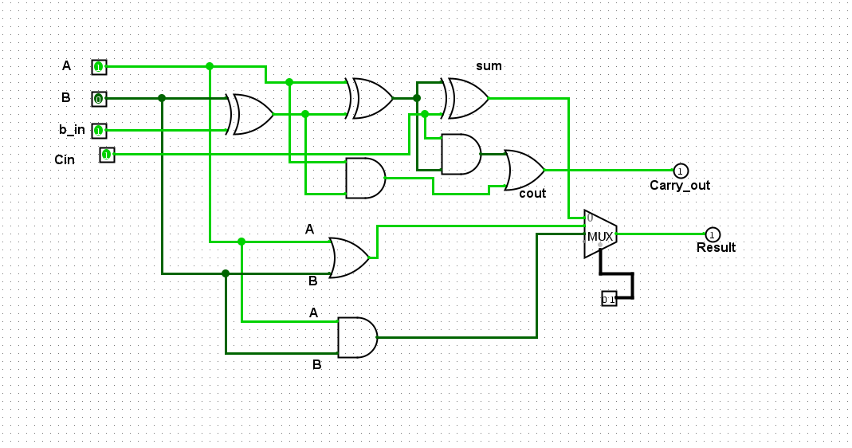
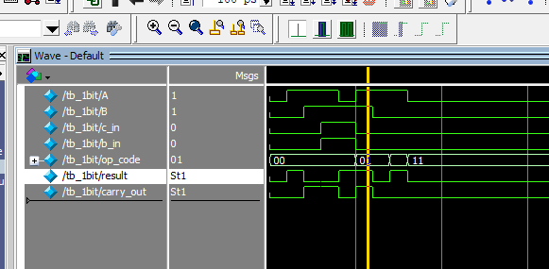

Task 2:

Description:
This task extends the 1-bit ALU into a 4-bit ALU by connecting four ALU modules.It supports addition, subtraction, AND, OR, and signed set-less-than (SLT).Carry signals pass between stages to perform multi-bit arithmetic.The circuit generates carry, sign, zero, and overflow flags.A Verilog testbench verifies the operations with different 4-bit inputs.

Code:
// Paste source code here 👇

module adder_1bit(input A, input B, input cin, input b_in, output res, output cout);

// b_in = 0 for addition
// b_in = 1 for subtraction
wire B_invert;

xor(B_invert, B, b_in);

wire r1, a1, a2;

xor(r1, B_invert, A);

and(a1, A, B_invert);

xor(res, r1, cin);

and(a2, r1, cin);

or(cout, a1, a2);

endmodule

// 1-bit ALU
module Alu_1bit(
input A, B,
input cin, b_in,
input [2:0] op_code,
input less,
output result, cout
);

wire and_result, or_result;
wire add_result;

wire s0_not, s1_not, s2_not;
wire w0, w1, w2, w3, w4;
wire add_select;

// logical operations
and(and_result, A, B);
or(or_result, A, B);

// addition and subtraction
adder_1bit add1(
.A(A),
.B(B),
.cin(cin),
.b_in(b_in),
.res(add_result),
.cout(cout)
);

// MUX selection logic
not(s0_not, op_code[0]);
not(s1_not, op_code[1]);
not(s2_not, op_code[2]);

// ADD (000) or SUB (001)
and(add_select, s2_not, s1_not);

and(w0, add_result, add_select);

// AND (010)
and(w1, and_result, s2_not, op_code[1], s0_not);

// OR (011)
and(w2, or_result, s2_not, op_code[1], op_code[0]);

// SLT (100)
and(w3, less, op_code[2], s1_not, s0_not);

// Reserved for additional operation
buf(w4, 1'b0);

// Final selected result
or(result, w0, w1, w2, w3, w4);

endmodule

// 4-bit ALU using four 1-bit ALUs
module ALU_4bit(
input [3:0] A,
input [3:0] B,
input [2:0] op_code,
output [3:0] result,
output CF, SF, ZF, OF
);

wire b_in;
wire c1, c2, c3, c4;

wire [3:0] alu_result;

wire slt_result;
wire subtraction_sign;
wire overflow_internal;

// SUB and SLT require subtraction
assign b_in = (op_code == 3'b001) ||
(op_code == 3'b100);

// first 1-bit ALU
Alu_1bit alu0(
.A(A[0]),
.B(B[0]),
.cin(b_in),
.b_in(b_in),
.op_code(op_code),
.less(slt_result),
.result(alu_result[0]),
.cout(c1)
);

// second 1-bit ALU
Alu_1bit alu1(
.A(A[1]),
.B(B[1]),
.cin(c1),
.b_in(b_in),
.op_code(op_code),
.less(1'b0),
.result(alu_result[1]),
.cout(c2)
);

// third 1-bit ALU
Alu_1bit alu2(
.A(A[2]),
.B(B[2]),
.cin(c2),
.b_in(b_in),
.op_code(op_code),
.less(1'b0),
.result(alu_result[2]),
.cout(c3)
);

// fourth 1-bit ALU
Alu_1bit alu3(
.A(A[3]),
.B(B[3]),
.cin(c3),
.b_in(b_in),
.op_code(op_code),
.less(1'b0),
.result(alu_result[3]),
.cout(c4)
);

// Signed comparison for SLT
// Sign of A-B = A[3] XOR B[3] XOR c3
xor(subtraction_sign, A[3], B[3], 1'b1, c3);

// Signed arithmetic overflow
xor(overflow_internal, c3, c4);

// SLT = sign of subtraction XOR overflow
xor(slt_result, subtraction_sign, overflow_internal);

// Final result -> buff only copy on thing to other a empty gate or just a connection
buf(result[0], alu_result[0]);
buf(result[1], alu_result[1]);
buf(result[2], alu_result[2]);
buf(result[3], alu_result[3]);

// Carry flag for addition and subtraction
assign CF = ((op_code == 3'b000) ||
(op_code == 3'b001)) ? c4 : 1'b0;

// Sign flag
buf(SF, result[3]); // it will copy the MSB of the result if MSB is 1 which me the answer is neqative

// Zero flag
nor(ZF, result[0], result[1], result[2], result[3]); // if result all bits are zero which mean they are equal
// if substraction was performed on equal A , B and it nor will invert the final
// answer the result all bit if zero then it will invert to 1 and will assign it to
// to ZF (zero flag) mean they are equal

// Overflow flag for ADD and SUB
assign OF = ((op_code == 3'b000) || (op_code == 3'b001)) ? overflow_internal : 1'b0; // it will set the flag only when the opcode is for ADD or SUB
// other wise it will assign a one bit zero to it 1'b0

endmodule

// Testbench
module tb;

reg [3:0] A, B;
reg [2:0] op_code;

wire [3:0] result;
wire CF, SF, ZF, OF;

ALU_4bit uut(
.A(A),
.B(B),
.op_code(op_code),
.result(result),
.CF(CF),
.SF(SF),
.ZF(ZF),
.OF(OF)
);

initial begin

A=4'b0101; B=4'b0011; op_code=3'b000;
#10;

A=4'b1111; B=4'b0001; op_code=3'b000;
#10;

A=4'b0111; B=4'b0011; op_code=3'b000;
#10;

A=4'b1000; B=4'b0011; op_code=3'b001;
#10;

A=4'b0011; B=4'b0101; op_code=3'b001;
#10;

A=4'b1100; B=4'b1010; op_code=3'b010;
#10;

A=4'b1111; B=4'b0000; op_code=3'b010;
#10;

A=4'b1010; B=4'b0101; op_code=3'b011;
#10;

A=4'b1000; B=4'b0001; op_code=3'b011;
#10;

A=4'b0011; B=4'b0101; op_code=3'b100;
#10;

A=4'b0111; B=4'b0010; op_code=3'b100;
#10;

A=4'b1101; B=4'b0010; op_code=3'b100;
#10;

A=4'b0111; B=4'b1000; op_code=3'b100;
#10;

A=4'b0100; B=4'b0100; op_code=3'b100;
#10;

end

endmodule
Output:
// Import output here 👇

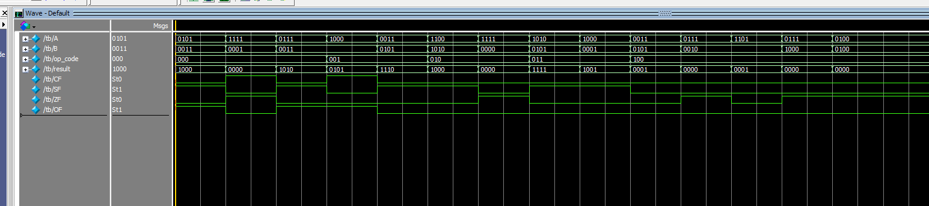

Task 3:

Description:
This task designs a parameterized ALU that can work with different bit widths.It supports ADD, SUB, AND, OR, XOR, and XNOR operations.A 3-bit opcode selects an operation using gate-level multiplexer logic.A generate loop builds the selection circuit for every result bit.The testbench uses an 8-bit configuration to check the operations.

Code:
module ALU #(parameter bits_len = 32) ( input [bits_len-1:0] A , input [bits_len-1:0]B, input [2:0]op_code , output [bits_len -1:0] result );

wire [bits_len - 1:0] add_result;
wire [bits_len - 1:0] sub_result;
wire [bits_len - 1:0] and_result;
wire [bits_len - 1:0] or_result;
wire [bits_len - 1:0] xor_result;
wire [bits_len - 1:0] xnor_result;

assign add_result = A + B;
assign sub_result = A - B;
assign and_result = A&B;
assign or_result = A|B;
assign xor_result = A^B;
assign xnor_result = ~(A^B);

wire s0 , s1 , s2 ;

not (s0 , op_code[0]);
not (s1 , op_code[1]);
not (s2 , op_code[2]);

// now doing utilizing the mux for selection the right operation

wire [bits_len - 1:0] w0 , w1 , w2 , w3,w4 , w5 ;

genvar i;

generate
for ( i = 0 ; i < bits_len ; i = i + 1) begin : mux_gates

and(w0[i] , add_result[i] , s2 , s1 , s0);

and(w1[i] , sub_result[i] , s2 , s1 , op_code[0]);

and(w2[i] , and_result[i] , s2 , op_code[1] , s0);

and (w3[i] , or_result[i] , s2 , op_code[1] , op_code[0]);

and (w4[i], xor_result[i] , op_code[2] , s1 , s0 );

and (w5[i] , xnor_result[i] , op_code[2] , s1 , op_code[0]);

or (result[i] , w0[i] , w1[i] , w2[i] ,w3[i] , w4[i] , w5[i] );
end

endgenerate
endmodule

module test_bench_ALU;

// using 8 bit ALU we made the ALU which can perfrom any N bits operation
parameter width = 8;
reg [width - 1 :0] a , b;

reg [2:0] op;
wire [width - 1 :0] res;

ALU #(.bits_len(width) ) alu(.A(a) , .B(b) , .op_code(op) , .result(res) );

initial begin

// ADD opcode is 000
a = 'h0A; b = 'h0B; op = 3'b000;
#10;

// Test 2: ADD 255 + 1 = 256 (Carry = 1)
a = 'hFF; b = 'h01; op = 3'b000;
#10;

// Test 3: SUB 20 - 10 = 10
a = 'h14; b = 'h0A; op = 3'b001;
#10;
// Test 4: SUB 5 - 10 = -5
a= 'h05; b = 'h0A; op = 3'b001;
#10;

// Test 5: AND 11001100 & 10101010 = 10001000
a = 8'b11001100; b = 8'b10101010; op = 3'b010;
#10;

// Test 6: OR 11001100 | 10101010 = 11101110
a = 8'b11001100; b = 8'b10101010; op = 3'b011;
#10;

// Test 7: XOR 11001100 ^ 10101010 = 01100110
a = 8'b11001100; b = 8'b10101010; op = 3'b100;
#10;

// Test 8: XNOR 11001100 ^~ 10101010 = 10011001
a = 8'b11001100; b = 8'b10101010; op = 3'b101;
#10;

a = 'hFF; b = 'h0F; op= 3'b110;
#10;

// Test 10: operation which are not implemented yet will give a result of zero
a = 'hAA; b = 'h55; op = 3'b111;
#10;

end

endmodule
Output:
// Import output here 👇
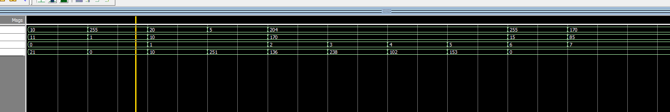

Task 4:

Description:
This task implements a parameterized ALU with arithmetic and logic operations.It also performs signed and unsigned comparisons using SLT and SLTU.The ALU supports logical left, logical right, and arithmetic right shifts.A 4-bit opcode selects the result through multiplexer logic.A zero flag is set when the final result equals zero.

Code:
module ALU #(parameter bits_len = 32)(
input [bits_len-1:0] a,
input [bits_len-1:0] b,
input [3:0] alu_op,
output [bits_len-1:0] result,
output zero
);

// Results of all operations
wire [bits_len-1:0] add_result;
wire [bits_len-1:0] sub_result;
wire [bits_len-1:0] and_result;
wire [bits_len-1:0] or_result;
wire [bits_len-1:0] xor_result;

wire [bits_len-1:0] slt_result;
wire [bits_len-1:0] sltu_result;

wire [bits_len-1:0] sll_result;
wire [bits_len-1:0] srl_result;
wire [bits_len-1:0] sra_result;

// Arithmetic operations

// Addition result
assign add_result = a + b;
// subtraction result
assign sub_result = a - b;

// Logical operations
// And operation
assign and_result = a & b;
// OR operation
assign or_result = a | b;
// XOR operation
assign xor_result = a ^ b;

// Comparison operations
// Signed setless than cheking
assign slt_result = ($signed(a) < $signed(b)) ? 1 : 0;
// Signed setless than cheking
assign sltu_result = (a < b) ? 1 : 0;

// Shift operations
// shift left operation
assign sll_result = a << b[4:0];
assign srl_result = a >> b[4:0];
assign sra_result = $signed(a) >>> b[4:0];

// Opcode inverted bits
wire s0, s1, s2, s3;

not(s0, alu_op[0]);
not(s1, alu_op[1]);
not(s2, alu_op[2]);
not(s3, alu_op[3]);

// MUX intermediate wires
wire [bits_len-1:0] w0, w1, w2, w3, w4;
wire [bits_len-1:0] w5, w6, w7, w8, w9;

genvar i;

generate
for(i = 0; i < bits_len; i = i + 1) begin : mux_gates

// 0000 ADD
and(w0[i], add_result[i], s3, s2, s1, s0);

// 0001 SUB
and(w1[i], sub_result[i], s3, s2, s1, alu_op[0]);

// 0010 AND
and(w2[i], and_result[i], s3, s2, alu_op[1], s0);

// 0011 OR
and(w3[i], or_result[i], s3, s2, alu_op[1], alu_op[0]);

// 0100 XOR
and(w4[i], xor_result[i], s3, alu_op[2], s1, s0);

// 0101 SLT
and(w5[i], slt_result[i], s3, alu_op[2], s1, alu_op[0]);

// 0110 SLTU
and(w6[i], sltu_result[i], s3, alu_op[2], alu_op[1], s0);

// 0111 SLL
and(w7[i], sll_result[i], s3, alu_op[2], alu_op[1], alu_op[0]);

// 1000 SRL
and(w8[i], srl_result[i], alu_op[3], s2, s1, s0);

// 1001 SRA
and(w9[i], sra_result[i], alu_op[3], s2, s1, alu_op[0]);

// Final MUX output
or(result[i],
w0[i], w1[i], w2[i], w3[i], w4[i],
w5[i], w6[i], w7[i], w8[i], w9[i]
);

end
endgenerate

// Zero flag
assign zero = (result == 0);

endmodule

module test_bench_ALU;

reg [31:0] a, b;
reg [3:0] alu_op;

wire [31:0] result;
wire zero;

ALU #(.bits_len(32)) alu (
.a(a),
.b(b),
.alu_op(alu_op),
.result(result),
.zero(zero)
);

initial begin

// Test 1: ADD 10 + 20 = 30
a = 32'd10; b = 32'd20; alu_op = 4'b0000;
#10;

// Test 2: SUB 20 - 5 = 15
a = 32'd20; b = 32'd5; alu_op = 4'b0001;
#10;

// Test 3: AND
a = 32'h000000CC; b = 32'h000000AA; alu_op = 4'b0010;
#10;

// Test 4: OR
a = 32'h000000CC; b = 32'h000000AA; alu_op = 4'b0011;
#10;

// Test 5: XOR
a = 32'h000000CC; b = 32'h000000AA; alu_op = 4'b0100;
#10;

// Test 6: SLT (-5 < 3) = 1
a = -5; b = 32'd3; alu_op = 4'b0101;
#10;

// Test 7: SLTU (5 < 10) = 1
a = 32'd5; b = 32'd10; alu_op = 4'b0110;
#10;

// Test 8: SLL (5 << 2) = 20
a = 32'd5; b = 32'd2; alu_op = 4'b0111;
#10;

// Test 9: SRL (16 >> 2) = 4
a = 32'd16; b = 32'd2; alu_op = 4'b1000;
#10;

// Test 10: SRA (-16 >>> 2) = -4
a = -16; b = 32'd2; alu_op = 4'b1001;
#10;

// Test 11: SUB 10 - 10 = 0, zero = 1
a = 32'd10; b = 32'd10; alu_op = 4'b0001;
#10;

// Test 12: SLT (10 < 5) = 0, zero = 1
a = 32'd10; b = 32'd5; alu_op = 4'b0101;
#10;

// Test 13: SLTU (-1 < 1 unsigned) = 0
a = 32'hFFFFFFFF; b = 32'd1; alu_op = 4'b0110;
#10;

// Test 14: Reserved opcode, result = 0
a = 32'd10; b = 32'd5; alu_op = 4'b1111;
#10;

end

endmodule
Output:
// Import output here 👇
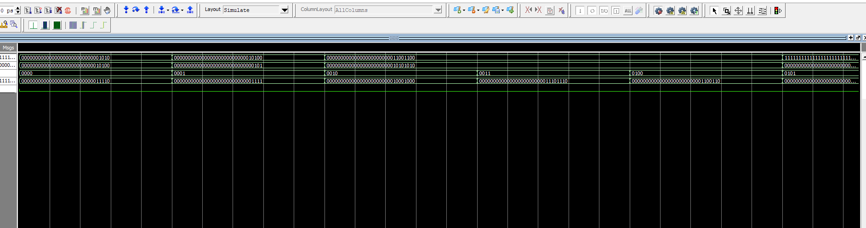
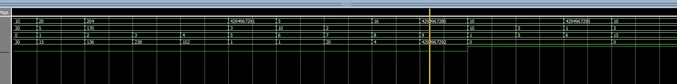

Task 5:

Description:
This task presents an ALU circuit designed in Logisim.
The circuit takes two binary inputs and processes them using multiple operations.
Logic gates and arithmetic blocks produce the different possible results.
A multiplexer selects the required output according to the control inputs.
An output indicator and zero detector help observe the circuit response.

